**5. Implementation**

**5.1 Layout**

**5.1.1 Login**

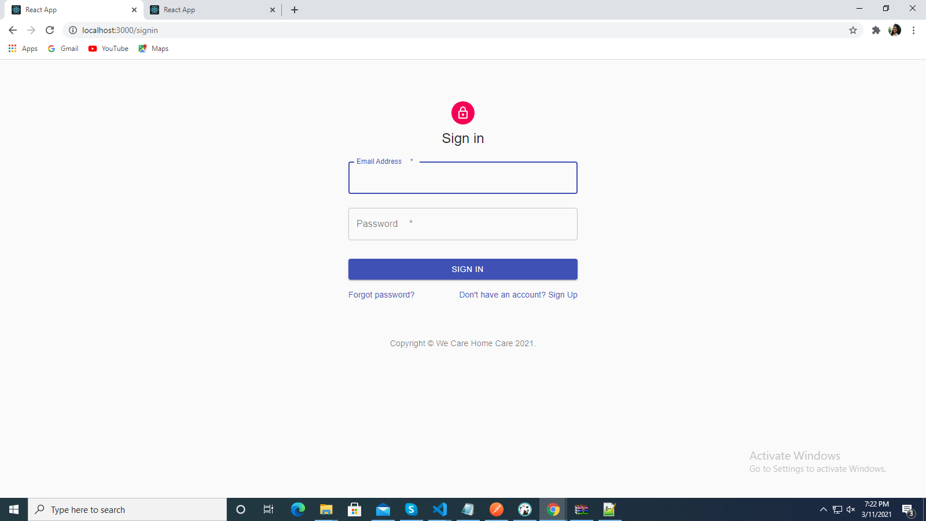

**5.1.2 Registration**

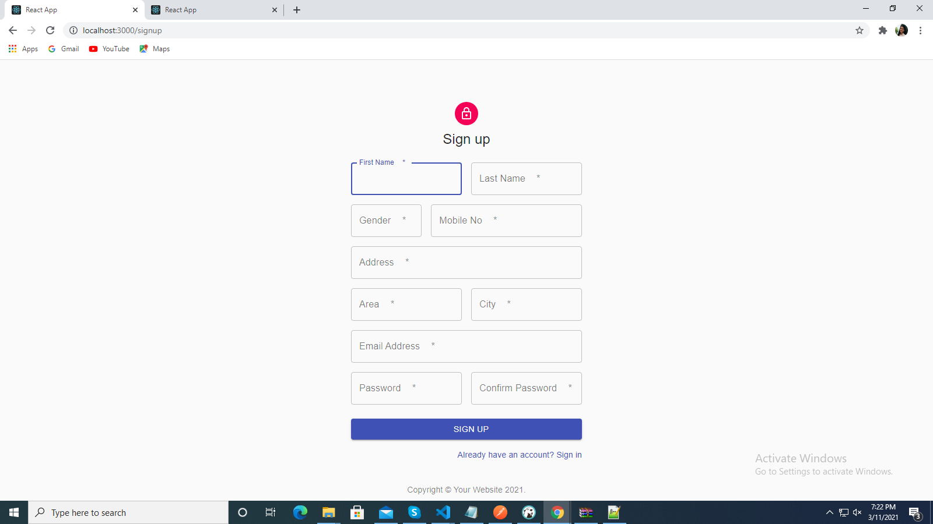

**5.1.3 Forget Password**

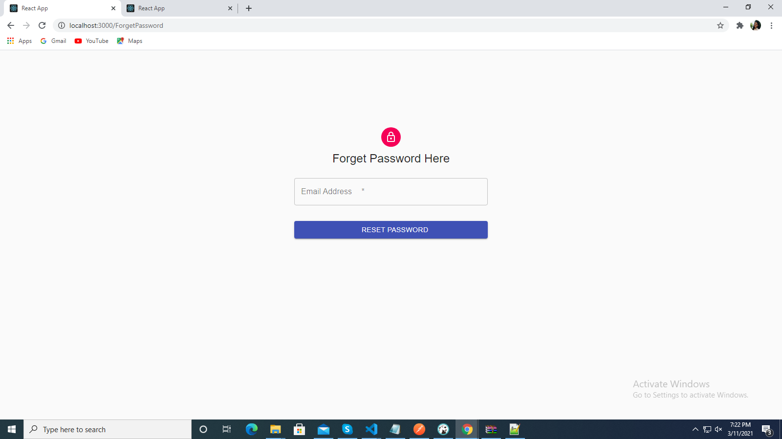

**5.1.4 Admin Dashboard**

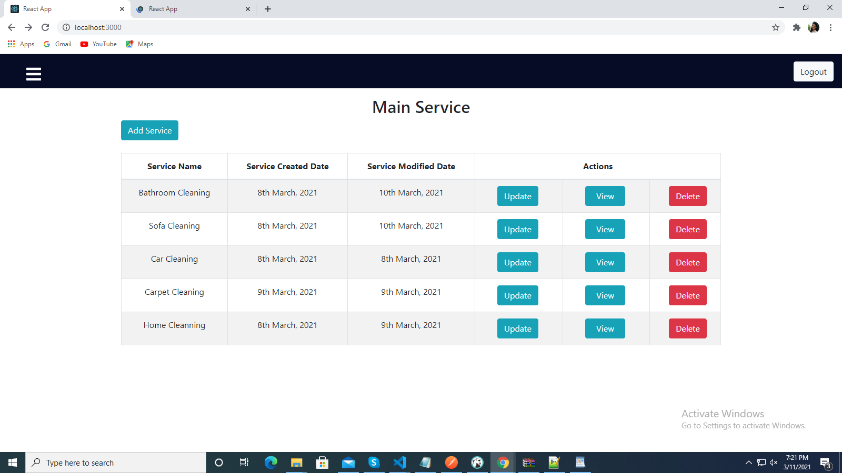

**5.1.5 Add Service**

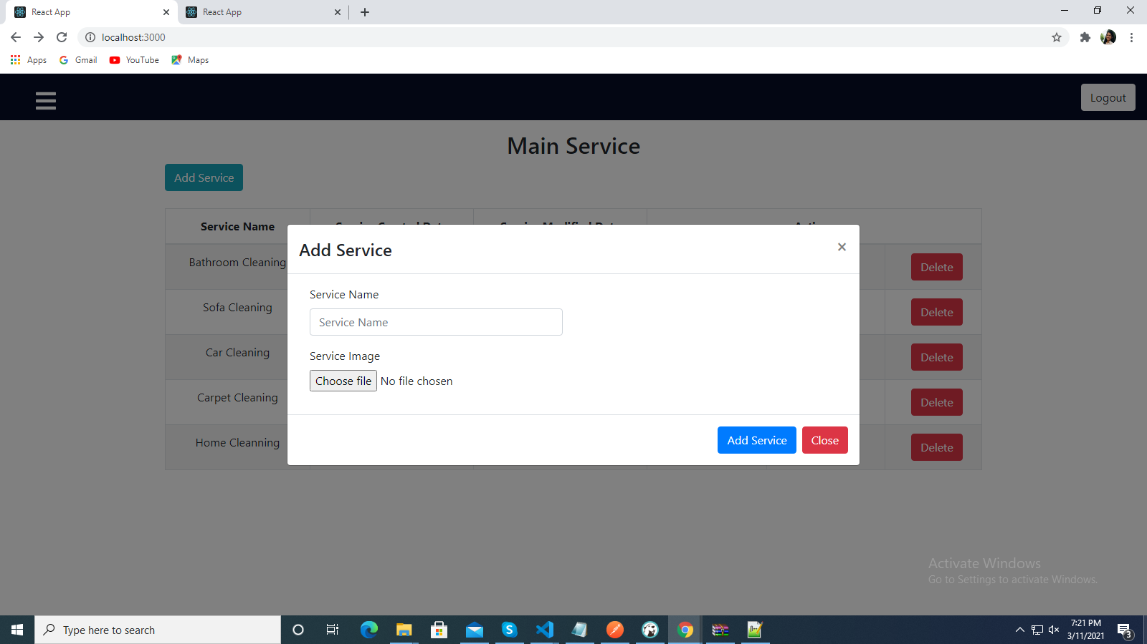

**5.1.6 Update service**

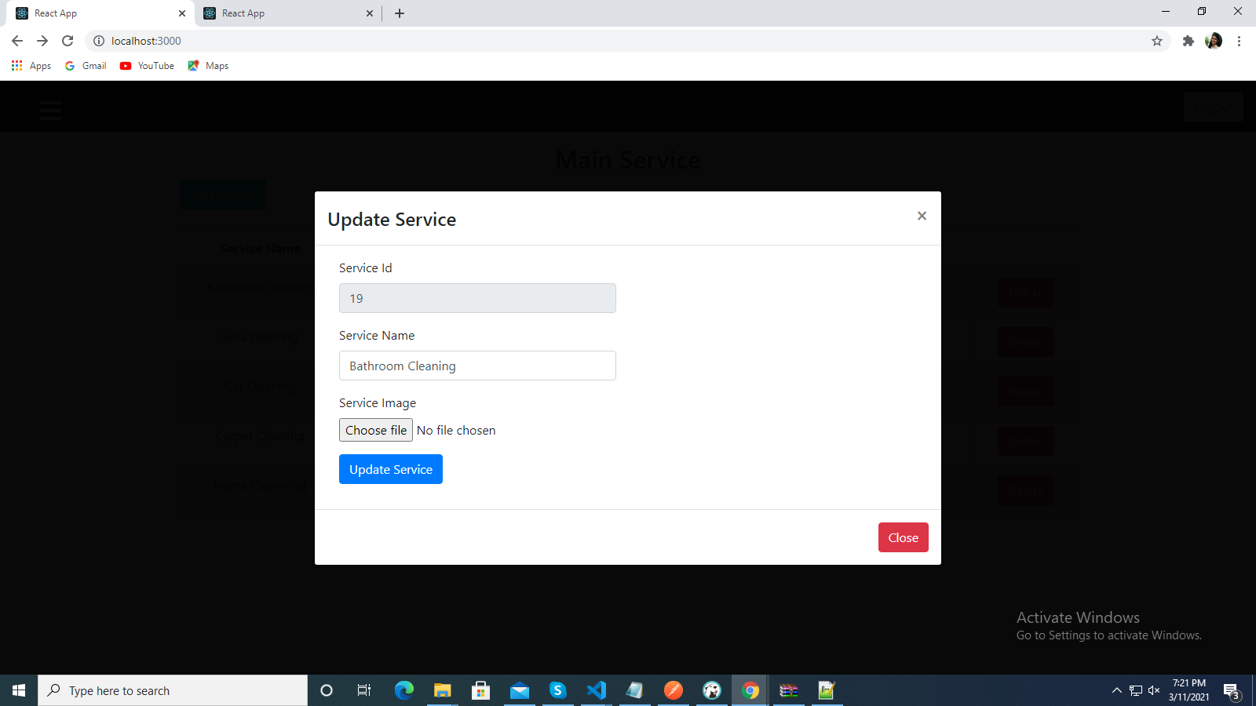

**5.1.7 View Subservices**

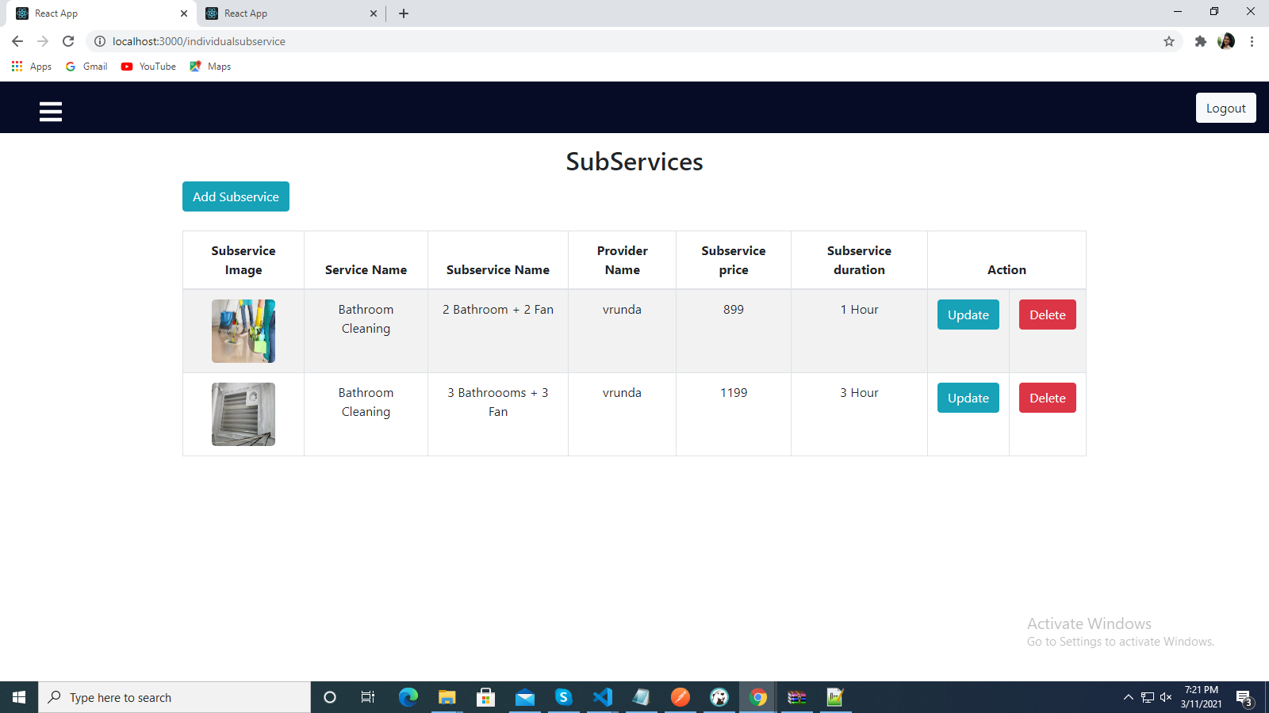

**5.1.8 View Customer**

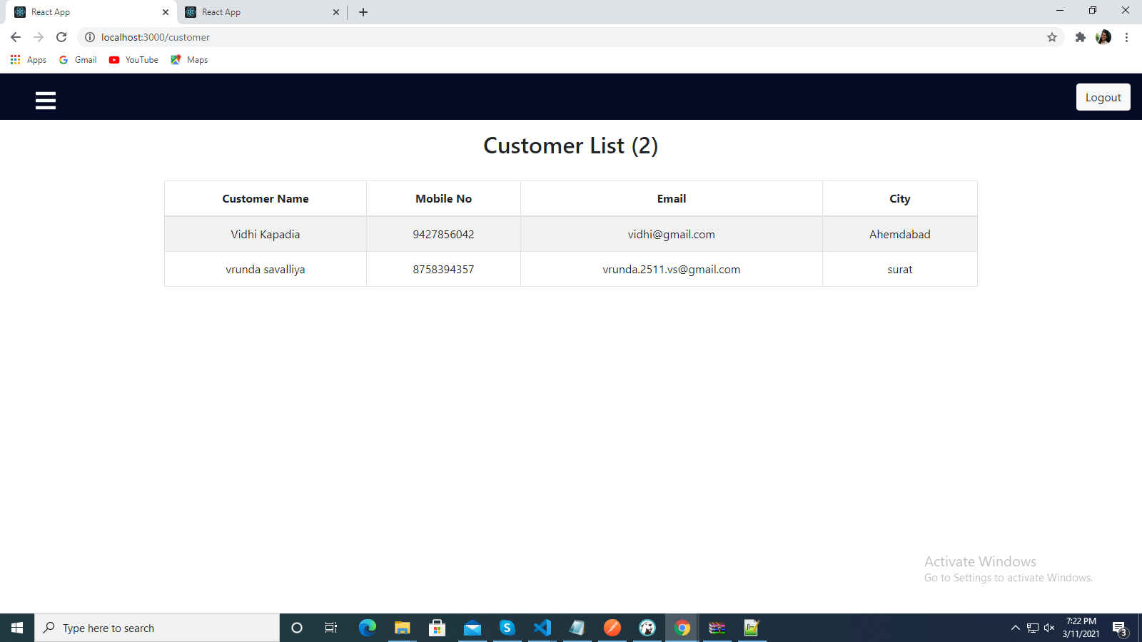

**5.1.9 View Feedback**

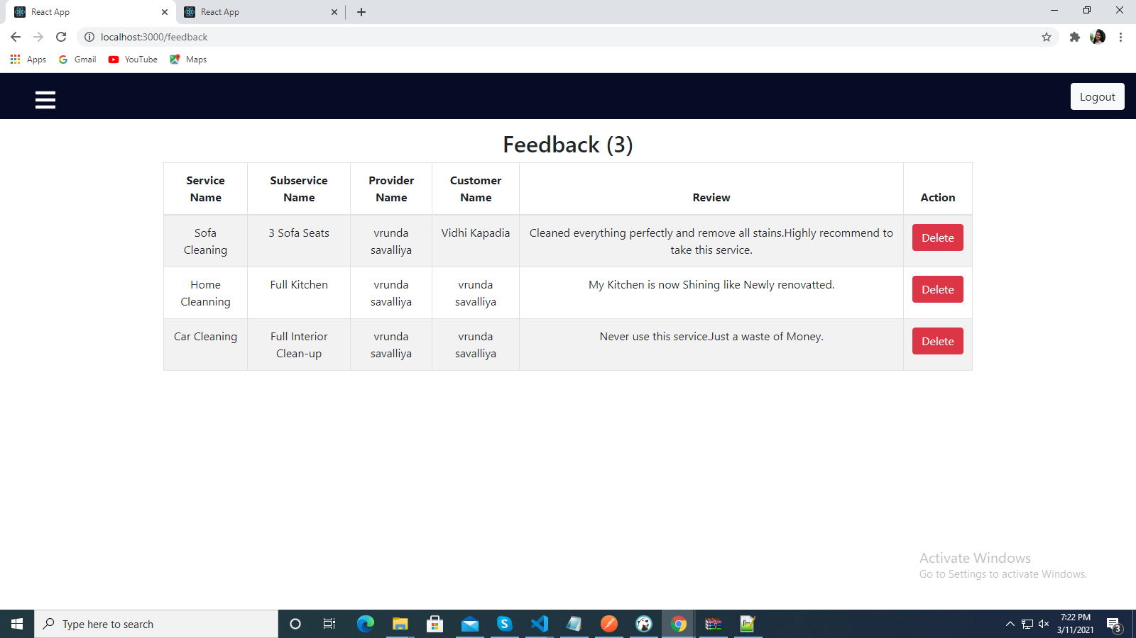

**5.1.10 View Provider**

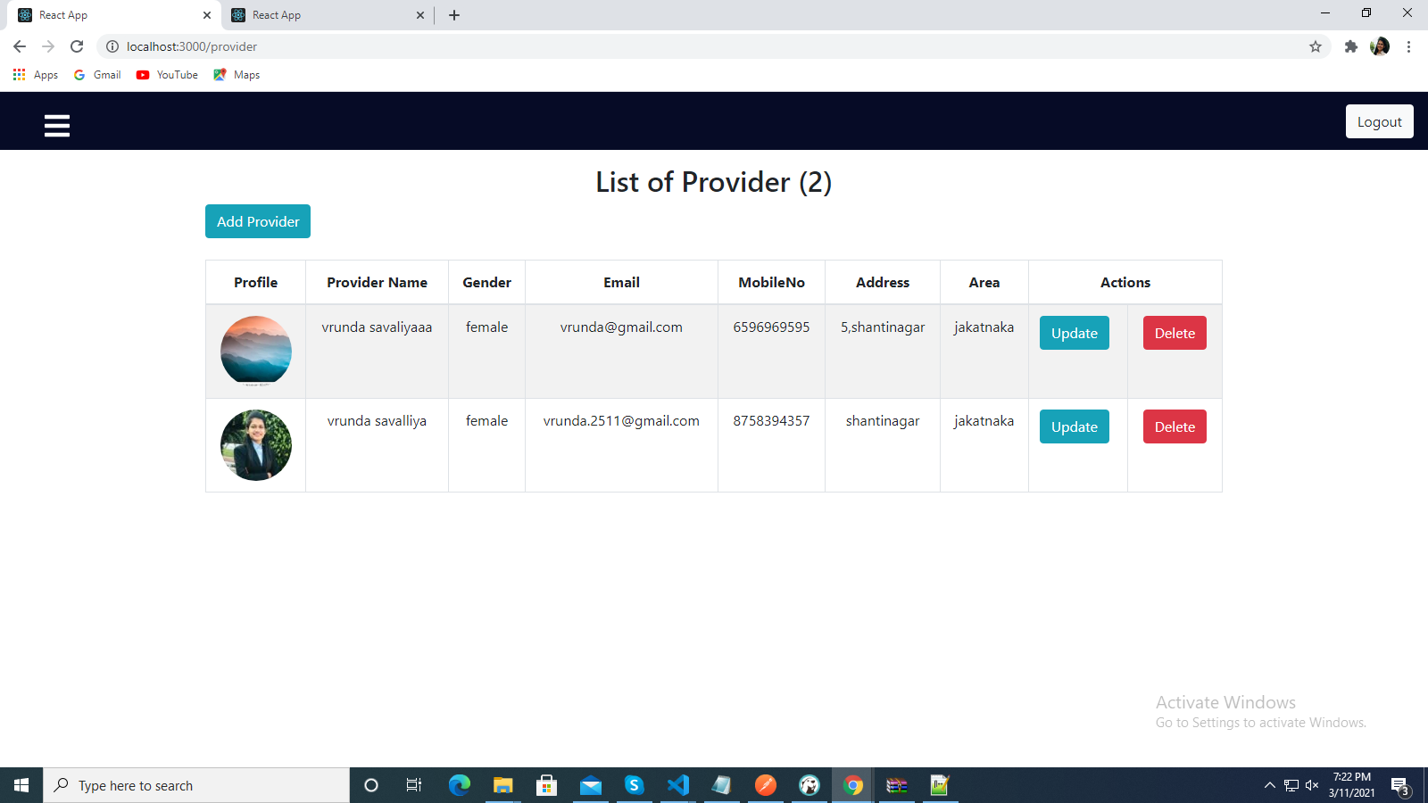

**5.1.11 View Order**

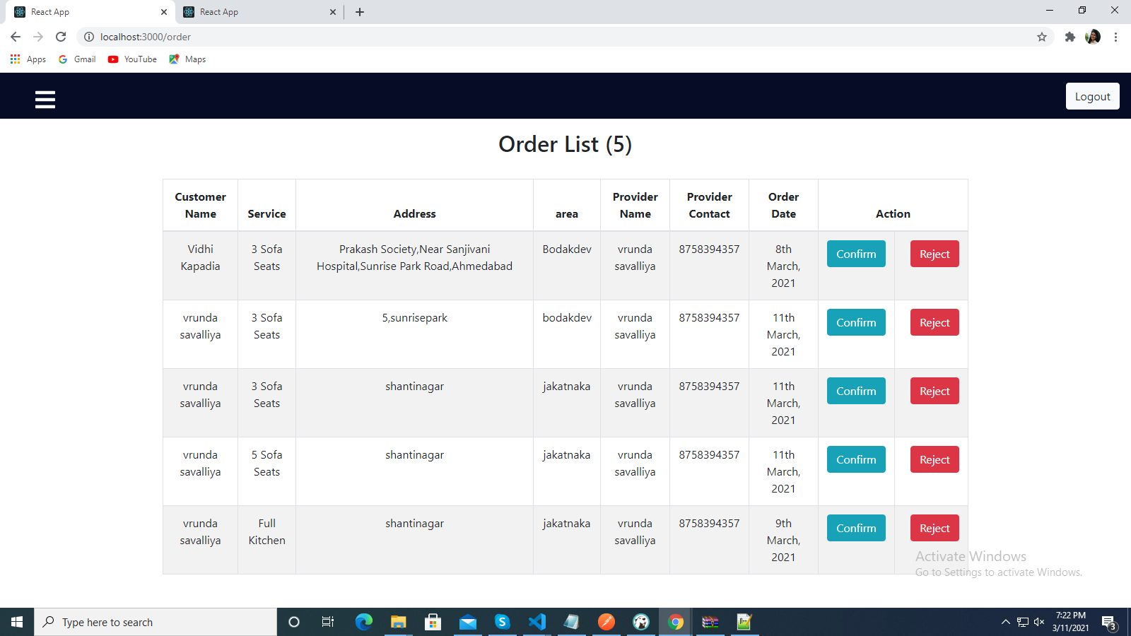

**5.1.12 Customer Dashboard**

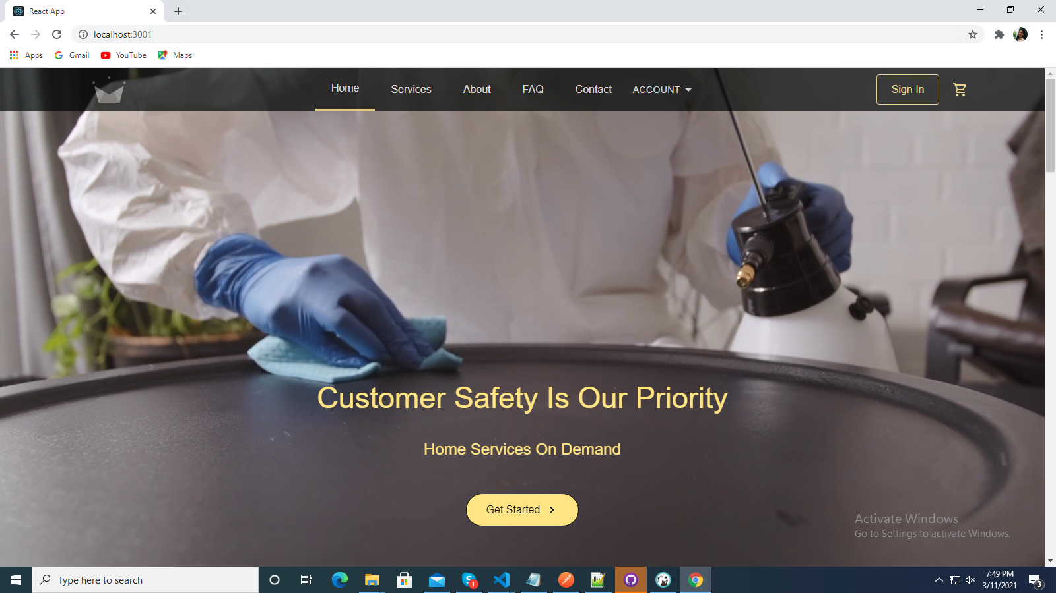

**5.1.13 View Services on customer dashboard**

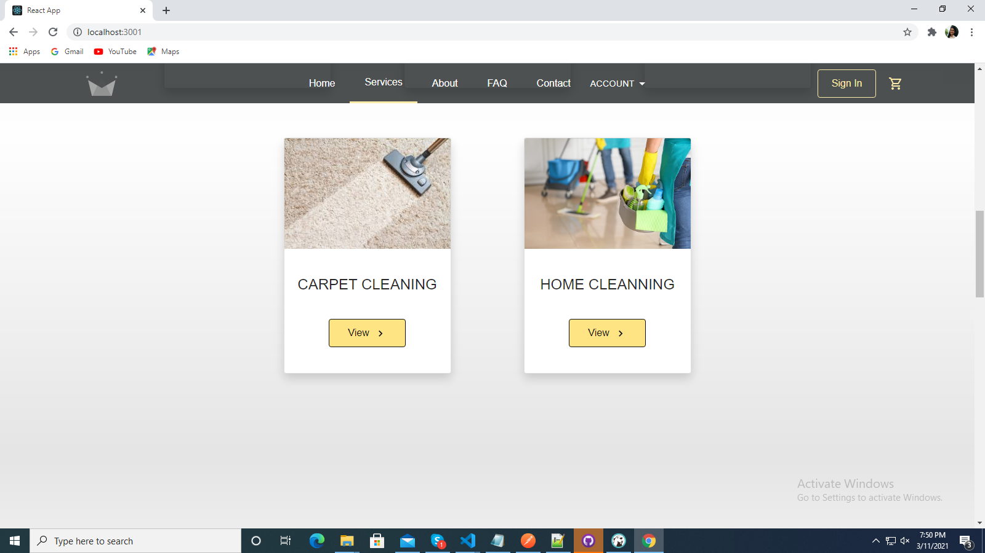

**5.1.14 view subservices Customer Dashboard**

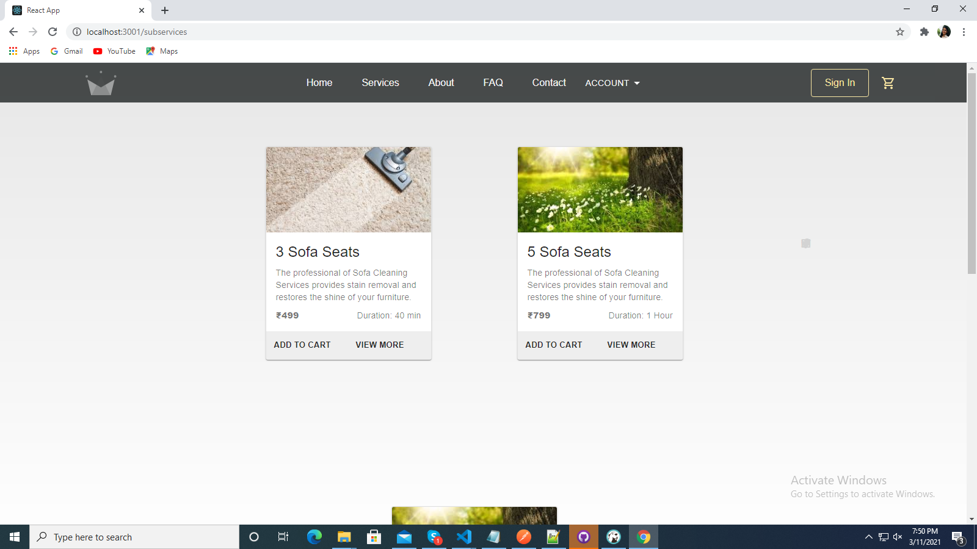

**5.1.15 Customer View cart**

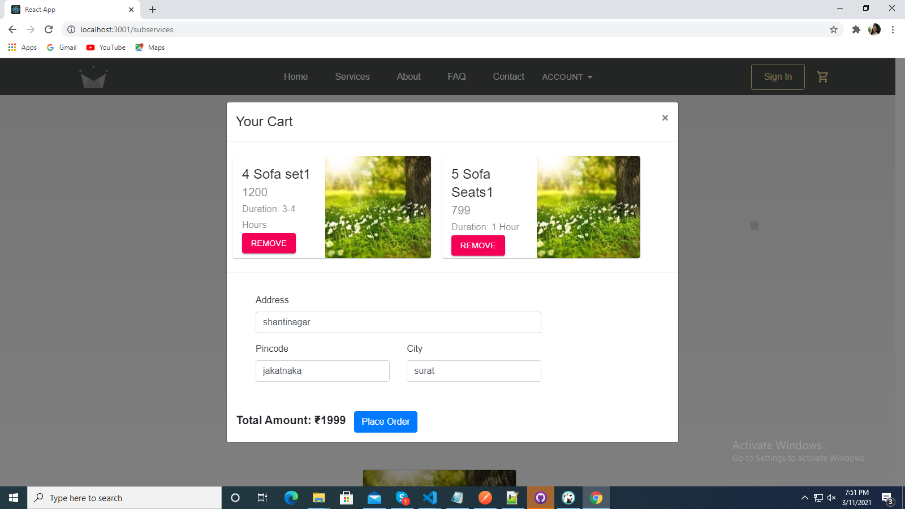

**5.1.16 Customer ViewProfile**

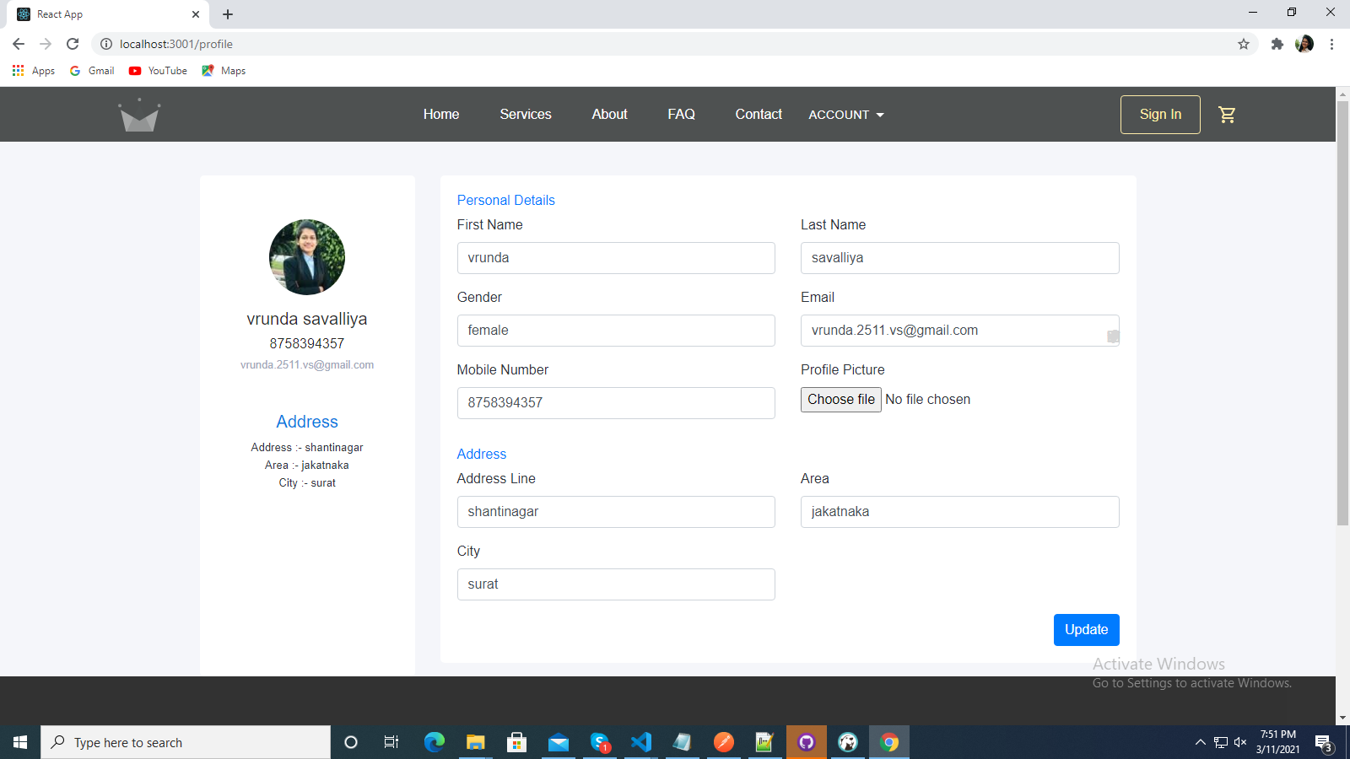

**5.1.17 Customer Order History**

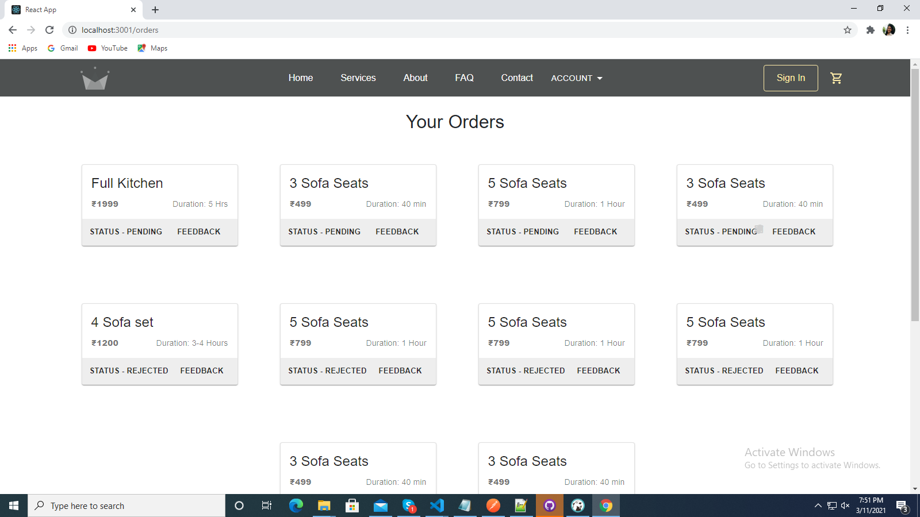

**5.2 Code Convention**

**5.2.1 Login**

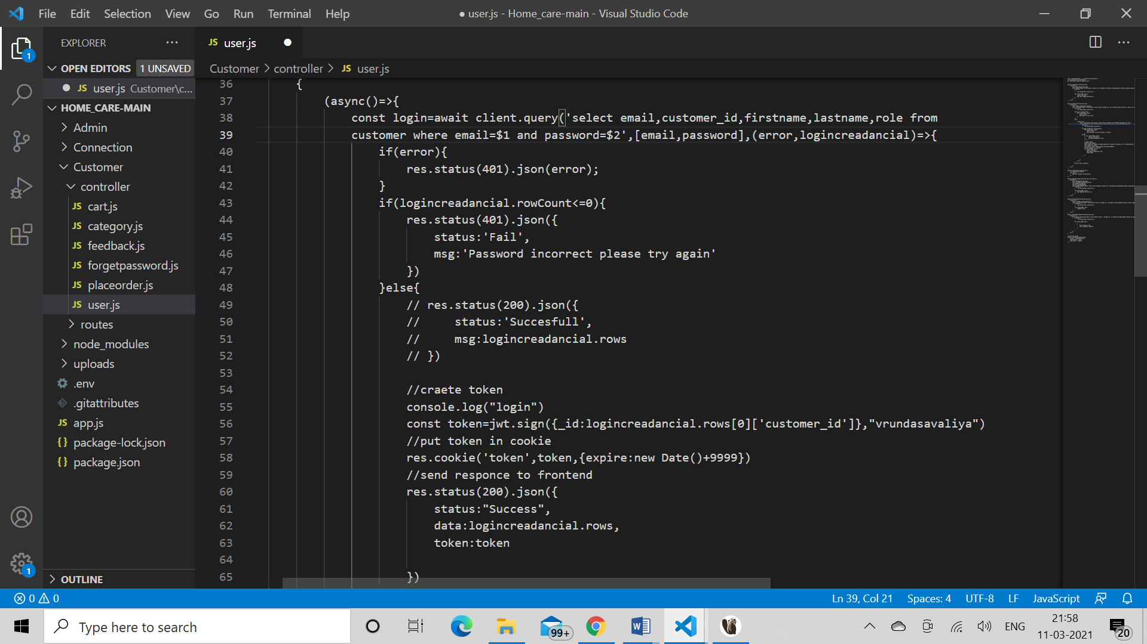

**5.2.2 Registration**

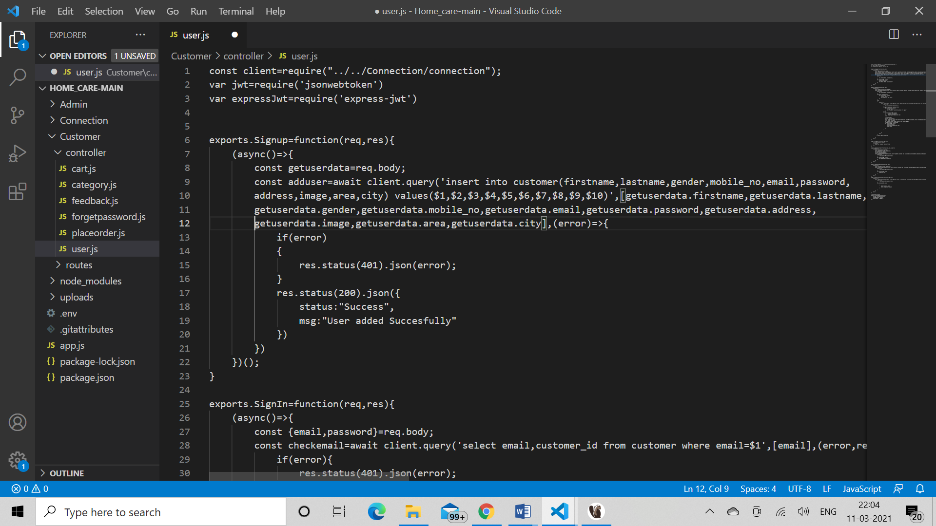

**5.2.3 Send Mail**

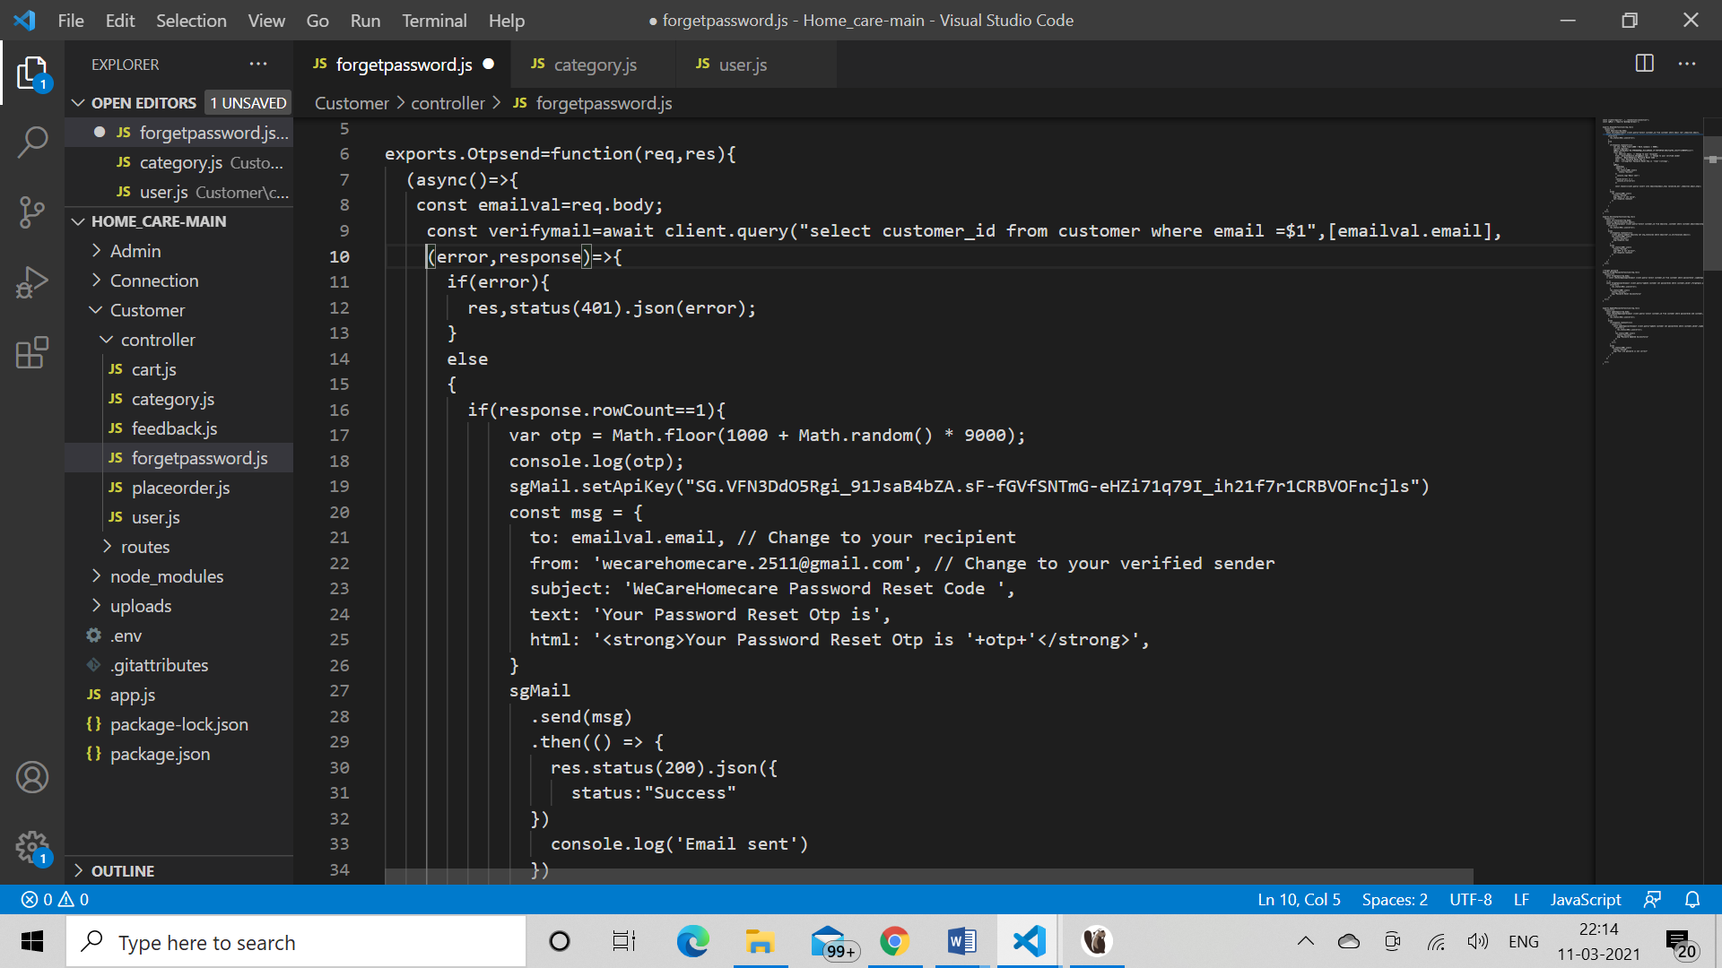

**5.2.3 Add Service**

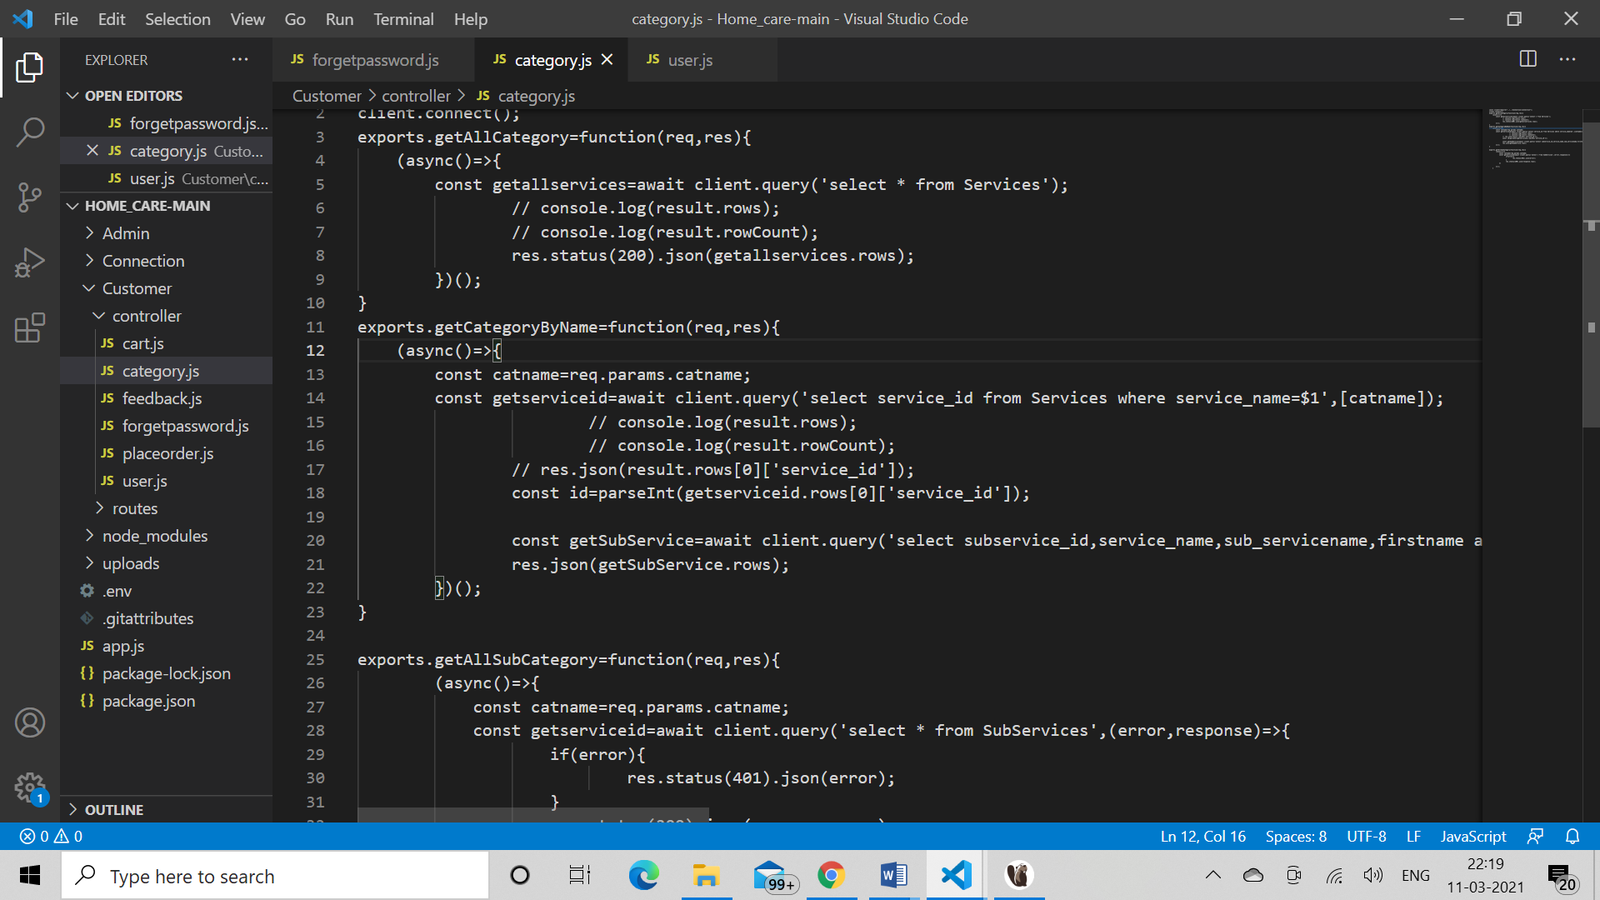

**5.2.4 Add to cart**

